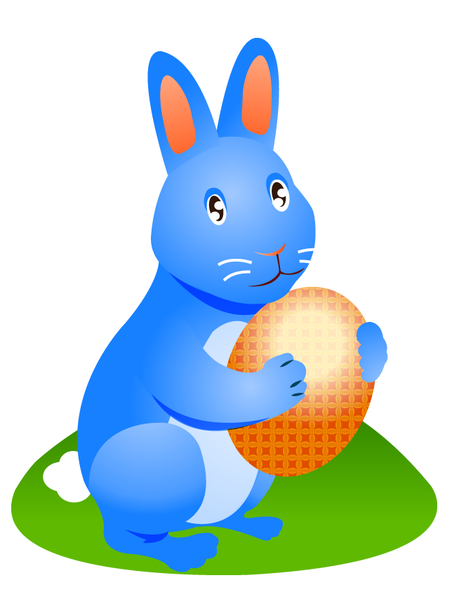
EGG-CELLENT READING ACTIVITIES
Mrs. Smith-Title One
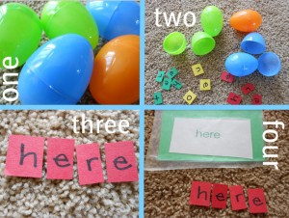
- Write your child’s spelling words on a piece of paper, spacing the letters apart. Cut the letters apart. Mix them up and put them into a plastic egg. Have your child open each egg and try to put the spelling word together. For extra fun, hide the Easter Eggs and have your child search for them before putting the words together.
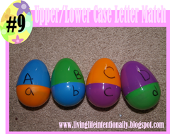
- Put your child’s sight words (You can find a grade level sight word list online at http://www.mrsperkins.com/dolch.htm) on a piece of paper. Make two copies of each word. Put each word into a plastics egg. Lay the eggs in a row on the floor or set them into several empty milk cartons. Play a game of Memory. Have your child read the words until they get a match. If they don’t get a match, the word goes back into an egg in the spot that it was found.
- For younger kids, match uppercase and lowercase letters by writing an Uppercase letter on the top half of the egg and a lowercase letter on the bottom half of the egg. Pull them apart and have your child identify and match the letters together.
- Read an Easter story and write a new story ending or decorate an Easter egg to go along with the story.
Here are some EGG-CELLENT Easter Fun books. I hope the Easter bunny doesn’t forget to “hop by” and drop one in your child’s Easter Basket! 